**Data Migration Script**

**Backing Up Data**

1. Make a folder called **Data Migration Script** in your external drive or just copy the folder here and skip step two.
2. Ensure you have the backup, restore, and import_pst.ps1
3. Run 00Backup - User Profile.bat as ADMIN (Use your credentials)
4. Type in your external drive’s drive letter.
5. Type in the user id of the person you want to save.
   1. Don’t know their ID? Check via C:\Users or ask them.
6. Wait for the script to finish.

**Example Backup**

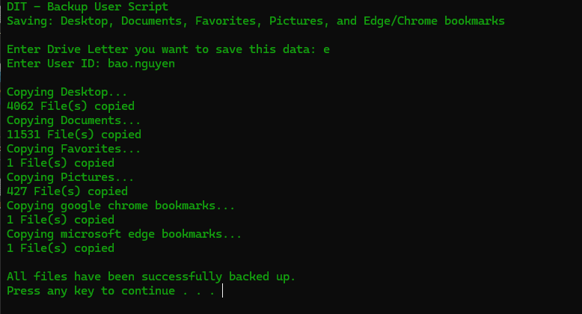

**Restoring Data**

1. Make sure the user has logged on to this computer at least once.
   1. If not, they will not have a profile on the PC to export this data to.
2. 00Restore - User Profile.bat
3. Type in your external drive’s drive letter.
4. Type in the user id of the person you want to restore.
5. Wait for the script to finish.

**Example Restore**

